REPORT FOR: | PERFORMANCE & FINANCE SCRUTINY SUB-COMMITTEES
Date of Meeting: | 16 July 2015
Subject: | Update on Council Tax Support Scheme Following Scrutiny Challenge Panel in November 2014
Responsible Officer: | Tom Whiting – Corporate Director of Resources
Scrutiny Lead Member area: | Councillor Stephen Wright – Policy Lead Member  Councillor Primesh Patel – Performance Lead Member
Exempt: | No
Wards affected: | All
Enclosures: | None

Section 1 – Summary and Recommendations

The report provides members with an officer update following last years review of the Council’s Council Tax Support Scheme by Scrutiny.

Recommendations:
That Scrutiny Members note the report and the actions carried out as set out in the report to Cabinet dated 11/12/2014.

Section 2 – Report

Introductory paragraph

In November 2014 the Overview and Scrutiny Committee carried out a
Challenge Panel review of the Council’s Council Tax Support Scheme. This
followed the localisation of Council Tax Support on 1/4/2013, but with a
simultaneous reduction in grant of ten per cent (10%).

The CTS Challenge Panel took place on the 27th October 2014 and the main
aims were to:

- explore the impact on Harrow’s residents of the introduction of the local council tax support scheme and the contribution it may be making to household debt problems

- understand how residents affected by the scheme are managing to make their Council Tax payments

- consider the findings of the CTS consultation to inform the development of the new scheme

- consider other schemes both London wide and nationally in relation to lessons learnt and how the findings can influence the development of the new scheme

The panel invited and heard evidence from Council officers, the Portfolio Holder, local voluntary organisations and charities

A response to the Scrutiny Panel’s findings was taken to Cabinet on 11/12/2014.

Current situation
The Council must consider whether to revise or replace its Council Tax Support scheme each financial year. As such it is necessary for Harrow to consider whether the scheme requires reviewing annually and must do this in time to ensure it has sufficient time to consult and determine the scheme
prior to the deadline set out in the legislation.

In June 2014, at the review of the scheme for 2015/16 financial year, Harrow, via, Cabinet, agreed to consultation on various additional draft scheme models. Cabinet subsequently decided not to change the scheme for the financial year 2015/16, and the Council agreed to continue with the existing scheme at the full Council meeting held on 22/01/2015.

Again in June 2015, at the review of the scheme for 2016/17 financial year, Cabinet agreed, after considering whether to review the scheme, that the scheme should not be revised or replaced. As such Harrow will continue with the CTS scheme currently in place, as previously adopted by Full Council, for the 2016/17 financial year.

Mitigations
Both Officers and the Councillor Sachin Shah, Portfolio Holder for Finance and Major Contracts, have listened and taken into account the findings of the Challenge Panel review.

From 1/4/2015, Harrow has

- Reduced Summons Court Costs by £10 to £120

- Allocated £215k to Access Harrow to put an additional 6 experienced Council Tax Officers on the telephones to help reduce waiting times

- Allocated £275 to the Harrow Emergency Relief Scheme to cover the withdrawl of £485k DWP funding from 2015/16

- Allocated £250k to fund the waiving of court / bailiff costs in cases where there is clear financial hardship

- Ring fenced £250k into a contingency fund to deal with future appropriate emergencies

Many of the suggestions recommended by the Panel have been taken on board and impacts on residents continue to be monitored.

How have other councils changed the support available?
From April 2015, only 42 councils (out of 326) are continuing to provide the levels of support available under the former Council Tax Benefit system, down from 45 in April 2014 and 58 in April 2013.
The most common change that local authorities have made from the former CTB system has been to introduce a “minimum payment” which requires everyone to pay at least some council tax regardless of income. From April 2015, 250 schemes include a minimum payment, up from 245 in April 2014 and 229 in April 2013.
Along with a minimum payment, councils can make other changes to CTS. The graph below summarises the components of the 326 local schemes in England. Some local authorities introduced more than one new measure (for example reducing the second adult rebate and introducing a band cap), so councils may be counted more than once.
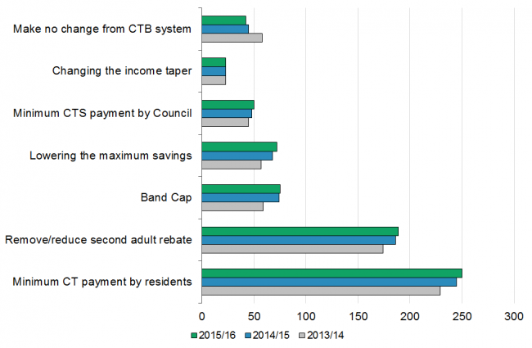
- 190 councils have reduced or removed the second adult rebate (the benefit homeowners not on a low income are entitled to if they share their home with someone on a low income), 4 more than April 2014 and 16 more than April 2013.
- 75 councils have introduced a band cap which involves limiting the amount of benefit received in higher value properties to the amount provided to those in lower value properties, one more than April 2014 (two councils introduced and one council removed a band cap) and 16 more than in April 2013. The most common band cap applied is D.
- 72 councils have lowered the maximum savings limit (the savings limit over which one is no longer eligible for council tax benefit), 4 more than in April 2014 (one council returned their savings limit to CTB levels of £16,000) and 15 more than in April 2013. Most reduced the threshold to £6,000 from £16,000.
- 50 councils have introduced a minimum CTS payment to residents, 2 more than April 2014 (one council removed its minimum CTS payment) and 5 more than in April 2013. A minimum CTS payment of £5 per week would mean that claimants entitled to less than this would receive nothing.
- 23 councils changed the income taper (the amount by which support is withdrawn as income increases) from the CTB rate of 20p per £1. The total that have changed the taper rate include 20 above the CTB rate and 3 below it. The overall number of councils that have a different rate from that under CTB has not changed since April 2013, although there have been rate changes between the years by some councils.

Minimum Payments
From April 2014, 245 schemes included a minimum payment, 16 more than in April 2013. From April 2015, this number increased to 250.
The size of this minimum payment varies by area; in 55 councils it is 8.5% or less of council tax liability and 53 councils it is over 20%. A minimum payment of 8.5% was common in the first year of CTS because grant funding was available to councils that did not withdraw support from claimants by more than 8.5% in the first year. In April 2013, 112 councils set their minimum payment at 8.5% or less.
The graph below shows the number of different councils by the level of minimum payment:
- There has been a large drop in the number of councils with smaller minimum payments levels (of 8.5% or less); from 112 in April 2013 to 64 in April 2014 to 55 in April 2015.
- The number of councils with a minimum payment of between 8.5% and 20% in April 2015 was 66, up from 65 in April 2014 and 23 in April 2013.
- 76 councils had a minimum payment of 20% in April 2015, up from 69 in April 2014 and 53 in April 2013.
- 53 councils had a minimum payment over 20% in April 2015, up from 47 in April 2014 and 41 in April 2013.

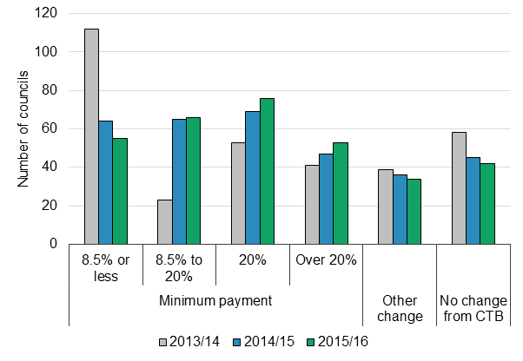
The above shows that more and more authorities have or are moving towards Harrow’s scheme thresholds.
The Future

The current administration has undertaken not to change the scheme until the end of the current administration. This is likely to mean that the current scheme remains in place until 2018/19. This being on the basis that there are no significant fundamental changes, either in caseload, demographics or the economy, which would require the Council to consider reviewing or replacing the scheme.

Modelling the current CTS caseload commitments and estimating 2016/17 expenditure, would suggest future expenditure in the region of £14m to £14.5 in the next financial year (including the 2% council tax inflation). This is in line with budgeted expenditure.

Graph 1 Expenditure
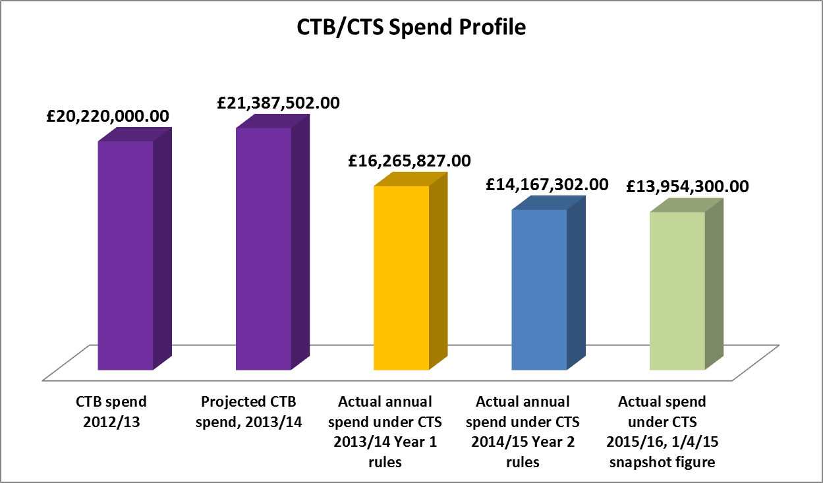

Future years expenditure is likely to rise slightly to reflect any council tax inflation applied. However expenditure is not expected to rise due to higher caseloads.

Graph 2 Caseload
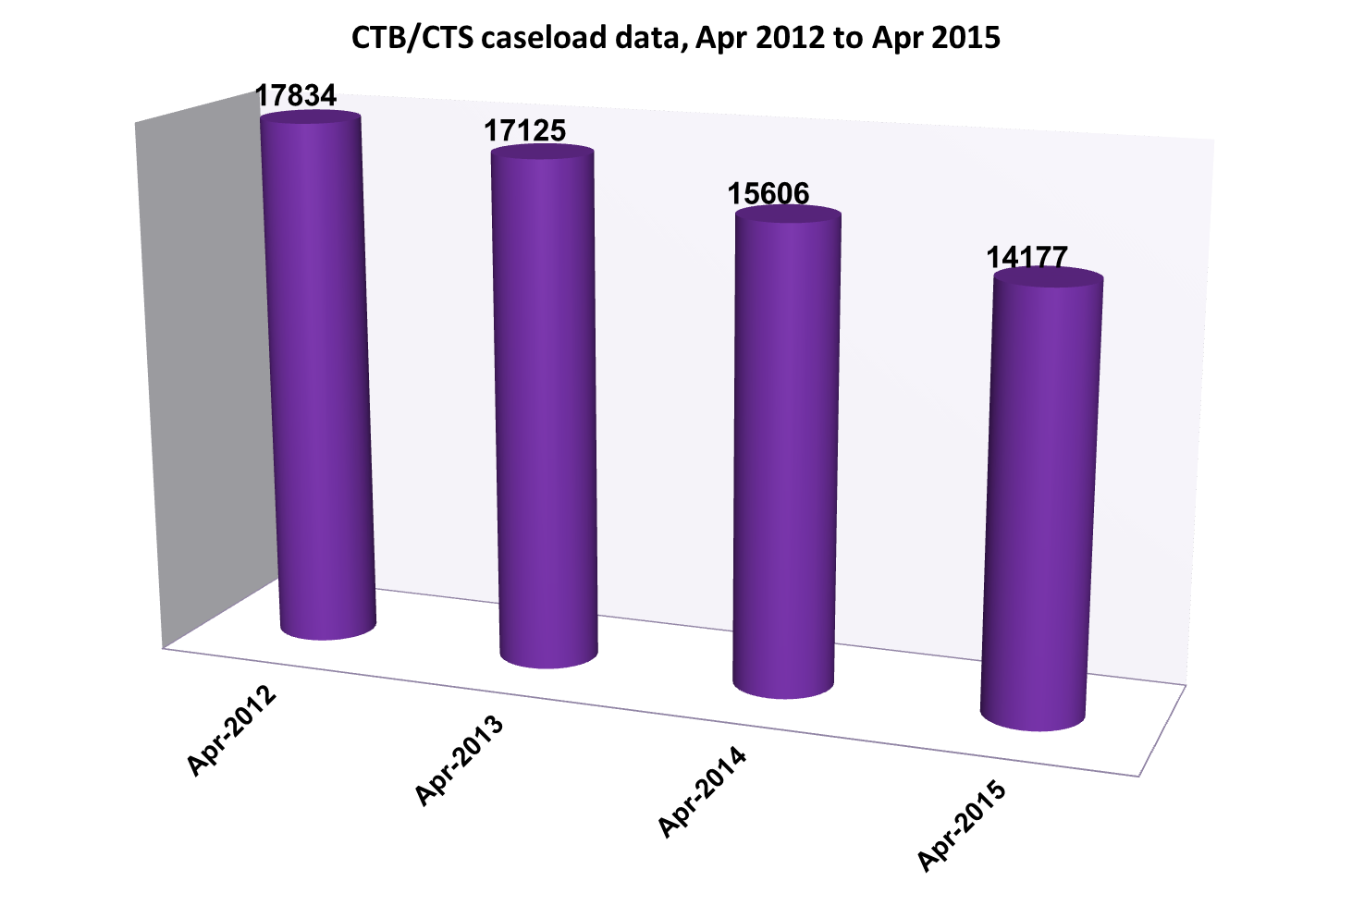

Council Tax collection rates in 2014/15 for CTS recipients reached 89% in year which was also above the 70% profile anticipated, resulting in overall collection rates for Council Tax of 97.3% in year. Overall Council Tax collection rates were higher in 2014/15 than the 97% achieved in year for 2013/14. It would appear that collection rates are settling down as claimants get used to having to pay some Council Tax.

Graph 3 Collection Rates
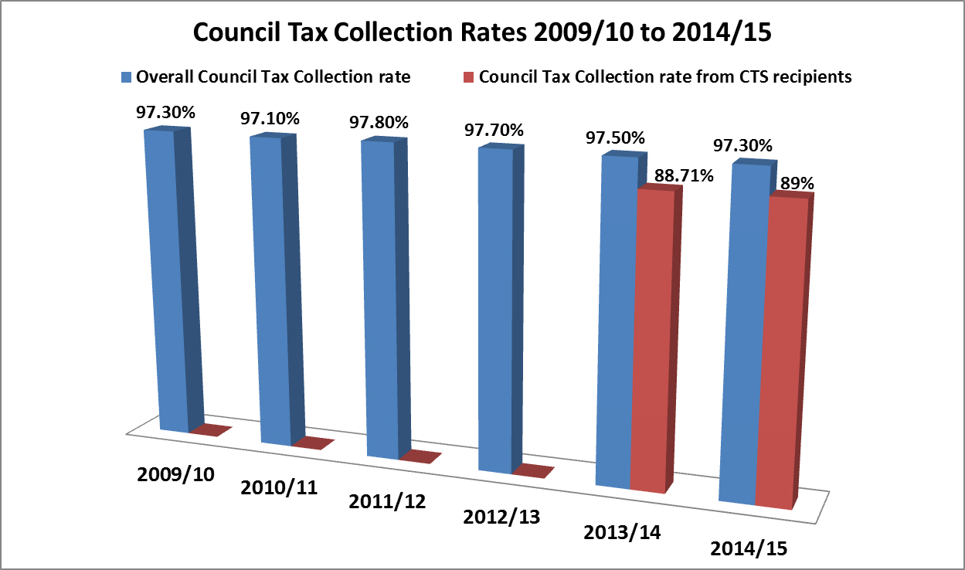
Progress against Scrutiny Challenge Recommendations

Scrutiny Panel Recommendations – page 21
- That the Council adopts the pre-consultation exercise undertaken by Adult Services as a principle of best practice for all future CTS consultations.
Update
Agreed and incorporated into process.

- That the Council ensure better engagement with vulnerable groups including those with language barriers.
Update
Agreed and process will be improved when we next consult.

- That the lawfulness of the recent consultation is reviewed in light of the Haringey Judgment as well as the lawfulness of any of the proposed changes.
Update
The Haringey case law and guidance will be taken into account for future consultations.

- That the Council identify the most vulnerable groups affected by any future proposed changes to the Scheme through consultations, with a view to exempting them from charges, and highlight this in consultation and Cabinet reports.
Update
Harrow already models any parameter configurations/proposed changes to the CTS scheme and therefore identifies impacts through modeling and the extensive EqIA that is always carried out against any proposed changes. This process already identifies all the impacted vulnerable groups.

Scrutiny Panel Recommendations – page 26
- That the Council (Portfolio Holder) writes to the Secretary of State and the Department for Work and Pensions (DWP) expressing concern regarding the long-term sustainability of the CTS Scheme with consideration given to cyclical and single shocks.
Update
Letter written and sent.

- That the Council write to the DWP requesting reduction of the Housing Benefit Taper which contributes to the Taper rate as a whole.
Update
Letter written and sent.

- The Council pro-actively encourages local businesses to pay the London Living Wage which has a knock on effect on residents’ ability to pay their Council Tax.
- Update
Agreed. This is an aspiration of the Administration.

- That the Council Tax collection policy is corrected and the assumption that all persons "can pay and won't” is removed as an approach. This Panel would like to see a debt recovery policy based on an individual’s ability to pay rather than a fixed point that they must pay by a certain end-point (31st March of each year).
Update
The current Council Tax policy does not work on this principle and caters for both those who can’t pay as well as those who won’t pay.

- That it is recognised as unacceptable that Harrow has the highest minimum payment (30%) of any London Borough and that the Scheme must be revised to bring the threshold down to the London average as a minimum.
Update
Whilst it is a fact that at 30% Harrow has one of the highest minimum payment for working age claimants, this was in order to ensure that disabled claimants, in the protected group, would have a lower minimum payment (currently 14%). As Cabinet recently decided not to change the scheme for 2016/17 there are no plans to change the taper percentage.

- That the Council should prioritise reducing the taper applied to working-age claimants as much as possible as it is a disincentive to work and encourage as many people as possible into jobs which will then reduce the cost of the Scheme and to the Council.
Update
Not agreed; While it is accepted that the taper is high, we do not believe that reducing the taper should be the priority.

- That the proposed collection rate should be set at 85% as opposed to the assumed 70% and the resulting planned increase in funds be used to reduce the taper down from 30%. This would support the Council's efforts to make work pay and assist workless or claimant households into (better) paid work.
Update
Not agreed. Increasing the budgeted amount that the Council aims to collect would lead to further pressure on families to pay more.

- That future reports to Cabinet and Council and future consultations include examples of what these changes would mean for the daily, weekly, monthly and yearly finances of households in receipt of CTS so that councillors’ can better appreciate the consequences of the CTS Scheme and proposed changes.
Update
Examples of weekly financial impacts were set out in the consultation documentation and were also in the CTS Cabinet report. Consideration will be given to how in future more information can be given so the wider Members are more aware of the implications.

- That research is carried out as to why other comparable boroughs introduced no CTS changes (e.g. Merton) or more minimal ones than Harrow (e.g. Redbridge).
Update
Whilst it is extremely useful to understand the rationale behind other Council’s decisions, we must understand that our own scheme has to comply with Harrow Council’s financial circumstances. The scheme was originally designed to ensure it was cost neutral as the Council was not in a position to spend extra funds beyond the grant that was passed on due to localisation.

Some research has been done, we know that the CTS scheme must not be looked at in isolation from the rest of a local authorities expenditure. This is because service priorities in one authority may be very different in another; resulting in varying funding allocation decisions based on local need and circumstances.

- That the Council identifies the level of cost-shunting onto other Council services e.g. Housing and Adults’/Children’s social care as a result of the CTS Scheme and steps be taken to mitigate or avoid this.
Update
Officers have recently reinstated the Welfare Reform Board who’s objectives are to understand the wider impacts of welfare reform, including CTS, and to ensure appropriate mitigations are considered.

- That the Council identifies the level of cost shunting to other parts of the Public Sector, e.g. NHS as a result of our CTS Scheme and steps be taken to mitigate or avoid this.
Update
As per the response to question 11.

Scrutiny Panel Recommendations – page 36
- That the Council should adopt a flexible approach at collection point offering residents affordable payment arrangements as every stage (after reviews) as an alternative to imposing a summons or referring a case to Bailiffs where a vulnerable person defaults once.
Update
The Council has a recovery policy which takes account of individual circumstances. However it must be noted that council tax is an annual charge which needs to be paid annually if the Council is to meet its budgeted income expectations. As such it may not be possible to administer effective collection without the court and subsequent recovery escalations.

Officers will be flexible within the remits of the overall business rules. Where exceptional cases are brought to officers’ attention, they will try and provide a bespoke service rather than the automatic escalations that are required to effectively deal with the vast majority of council tax payment defaulters.

- That the use of Bailiffs should be approved on a case by case basis by the Portfolio Holder responsible for Council Tax collection, and that this approval be granted on the basis of auditable evidence that a debtor can pay but is unwilling to pay, and has assets worth distraining upon.
Update
This is not possible within the available resources. The Portfolio Holder is responsible for formulation of policy, with officers making day to day operational decisions. It would not be appropriate for the Portfolio Holder to make decisions on individual cases.

As per the reply to question 1, officers will always consider individual circumstances when these come to our attention.

- That, considering the legal challenge to Haringey regarding their costs, the Council should reduce its unjustified (summons/liability orders) costs for CTS arrears to the actual court costs to the Council and defray other Council costs to the general fund.
Update
A re-calculation of costs has been carried out and lower costs of £120 have been introduced for the financial year 2015/16.

- that the Council should never seek committal where a person cannot pay.
Update
Committal is one of many options within the legislation for ensuring compliance with due payments, and as such no undertaking can be given that this recovery option will never be used.

- That the Council reviews its policy relating to Section 13A(1)(c) regarding its ability to remit debt.
Update
The Council will review this policy within the next 12 months.

- That the incentive structure of Harrow's bailiff contract be reviewed both by Cabinet and by Scrutiny as a matter of urgency.
Update
Harrow’s bailiff contract was changed coincide with the implementation of the “Taking Control of Goods Regulations 2013”, SI 1894. As such there is no longer an incentive structure within the bailiff contract.

Scrutiny Panel Recommendations – page 38
- That the Council review the code of practice for communication to customers when errors are identified (e.g., ensure there is an up-front apology) and consider paying compensation to CTS recipients
Update
This is all already covered in our corporate three staged complaint process.

- That the lack of accessibility to Council Tax collection staff for those in debt be urgently reviewed with a view to improving access and debt advice. All research has demonstrated that the most effective system of collecting debt is to communicate early and work with debtors with a supportive approach unless it is clear that the debtor can pay and won't.
Update
Whilst the Council’s channel shift and self service strategy will require more reductions in front office staff within Access Harrow, Harrow Council has already invested funds in our voluntary sector partners to ensure face to face debt advice is available. Harrow Council is also working with external partners and has contributed to the HAT (Harrow Advising Together project) which has created an advice portal to ensure advice is available and in in one easy place to access. The Council also extended its SLA with the CAB to maintain face to face appointments until 2015..

- That the Council ensures a sufficient number of benefit operators to reduce the waiting times for residents with CTS arrears to contact the Council
Update
Additional one off funding of £215k was allocated to Access Harrow for 2015/16 to put an extra 6 experienced operators on the telephones. This has already resulted in a much more improved service with lower waiting times.

- That the Council becomes more accessible to customers/CTS claimants trying to engage with the Council to discuss their CTS arrears with a special consideration given to the phone (pay as you go) costs to individuals trying to contact the Council.
Update
This question has already been answered by the response to question 2 & 3 above.

- That the Council establishes a direct line (contact) for organisations such as the Citizens’ Advice Bureau and the Law Centre etc supporting CTS claimants to be able to engage with the Council and get a rapid response.
Update
Harrow Council already works with external partners and where appropriate direct contact with back office services has been put in place.

Scrutiny Panel Recommendations – page 41
- That the Council review the eligibility criteria of the Emergency Relief Scheme, Hardship Fund and the Discretionary Housing Payment schemes and publicise these widely to ensure people are aware of them and increase the number of applications to these schemes.
Update
The DWP grant to fund the Emergency Relief Scheme ceased on the 31/3/15. Harrow has funded the service from 2015/16 by investing £275k in this area. As the budget is now only 50% of the 2014/15 one, it is not possible to widely publicise the service as the funds are only sufficient to meet existing demand.

Cabinet approved our Discretionary Housing Payments policy on the 18/7/2013 and it would be inappropriate to review this policy at this time considering there have been no fundamental changes which may have given rise to a reconsideration and additionally the DWP has cut funding by 40% for Harrow for the current financial year.

- That, if we cannot be confident that the fund will be spent on the right people at the right time, the Council considers transferring at least half of the fund from the Emergency Relief Scheme (which is underspent) back into the CTS Scheme to reduce the direct burden on some of the most vulnerable residents of Harrow.
Update
The Emergency Relief Scheme was fully spent in 2014/15 and we expect the reduced 2015/16 funding to also be fully spent.

- That, in line with the Portfolio Holder for Finance & Major Contracts’ comments regarding ring-fencing of funds for the Hardship Fund, that all monies raised through the CTS Scheme beyond covering the CTB-CTS shortfall be ring-fenced and used to reduce the overall CTS charge on households that fall within the scope of Harrow’s CTS Scheme.
Update
The commitment to ring fence the underspend on the CTS scheme and to utilize it on vulnerable people has occurred; £1m was indeed c’fwd and ringfenced into specific expenditure in 2015/16.

- That the impact on households with children (e.g. going into care, child poverty) be clearly identified and steps taken to better assist those households
Update
Whilst a holistic approach is our aspiration, this may not always be possible. The Revenues office already works with Children Services and Adults to ensure that vulnerability flags are put on specific council tax accounts. Specific checkpoints have been put in place to ensure we proceed differently where a household may be at risk or falls into one of our vulnerability categories. This is backed up by a vulnerability policy which ensures a more joined up approach within the resources available.

- That in keeping with the Council’s corporate priority of ‘Making a difference to the vulnerable’, a review of what is meant by ‘vulnerability’ is undertaken and that every Cabinet and Council paper include a section (like Equalities and Financial Implications) outlining the impact any proposed policy decision would have upon those deemed ‘vulnerable’.
Update
Harrow Council consulted on and reviewed its Corporate Debt Collection Policy on the 15/1/2014 and as a result implemented a vulnerability policy. As such it was not appropriate to review this area so soon after its introduction. Officers will however monitor the position and any lessons learn will be reflected in updates to the policy.

Financial Implications
The local CTS scheme takes up a sizeable percentage of the Council’s budget. The scheme currently runs within the allocated funding envelope but Harrow must review this regularly so expenditure is in line with budget availability and the Council’s overall financial position.

Performance Issues
Any future changes to the CTS scheme will impact either positively or negatively on collection rates, depending on whether the awards are higher or lower than those under the current scheme. The overall yield from council tax will also fluctuate as changes to the amount of CTS awarded will either increase or decrease the amount of tax to be collected.

Environmental Impact
N/A

Risk Management Implications
Collecting monies from claimants, who have previously received higher rates of CTS support, has been challenging and has increased risk to Council Tax collection. There is also the risk that robust enforcement of Council Tax may conflict with the wider corporate priorities. However processes have been changed over the past two years, and funding has been made available to both mitigate risk and support those in genuine financial hardship.

Equalities Implications
A comprehensive Equality Impact Assessment (EqIA) was undertaken in the
development of Harrow’s original Council Tax Support Scheme. The Council’s
completed equality impact assessment at that time still applies.

Council Priorities
The Harrow Council Tax Support Scheme reflects the aims of our corporate priorities thus ensuring we concentrate on supporting those who are financially vulnerable.

Section 3 - Statutory Officer Clearance

Name: Dawn Calvert |  |  | Chief Financial Officer
Date: 08/06/2015

Ward Councillors notified: | NO

Section 4 - Contact Details and Background Papers

Contact:
Fern Silverio (Head of Service – Collections & Housing Benefits),
Tel: 020-8736-6818 / email: fern.silverio@harrow.gov.uk

Background Papers:
Cabinet Report of the 11/12/2014 containing response to Challenge Panel questions

